17. Establishment of Bhikkhuni Sanghas Order
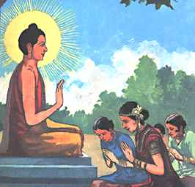
Maha Prajapati Gotami requests ordination as a nun from the Buddha. Three times s

he asks and is
.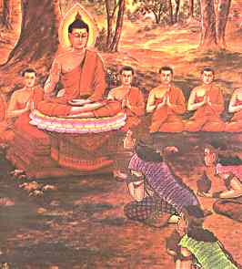
Three times Buddha refused her request
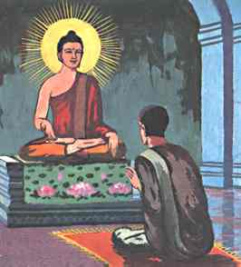
Ananda asks the Buddha three times if he would ordain the women and three times he says no. He then asks: 'Is it possible for women to get enlightened?' The Buddha agrees that it is and Ananda argues that surely women should be allowed this opportunity. The Buddha finally agrees - conditional on 8 points (basically placing the women as second to the men).
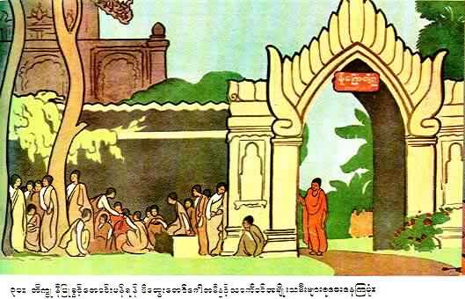
Pajapati Gotami and Usodhaya along with the royal maids wait for permission to be ordained as Nuns.
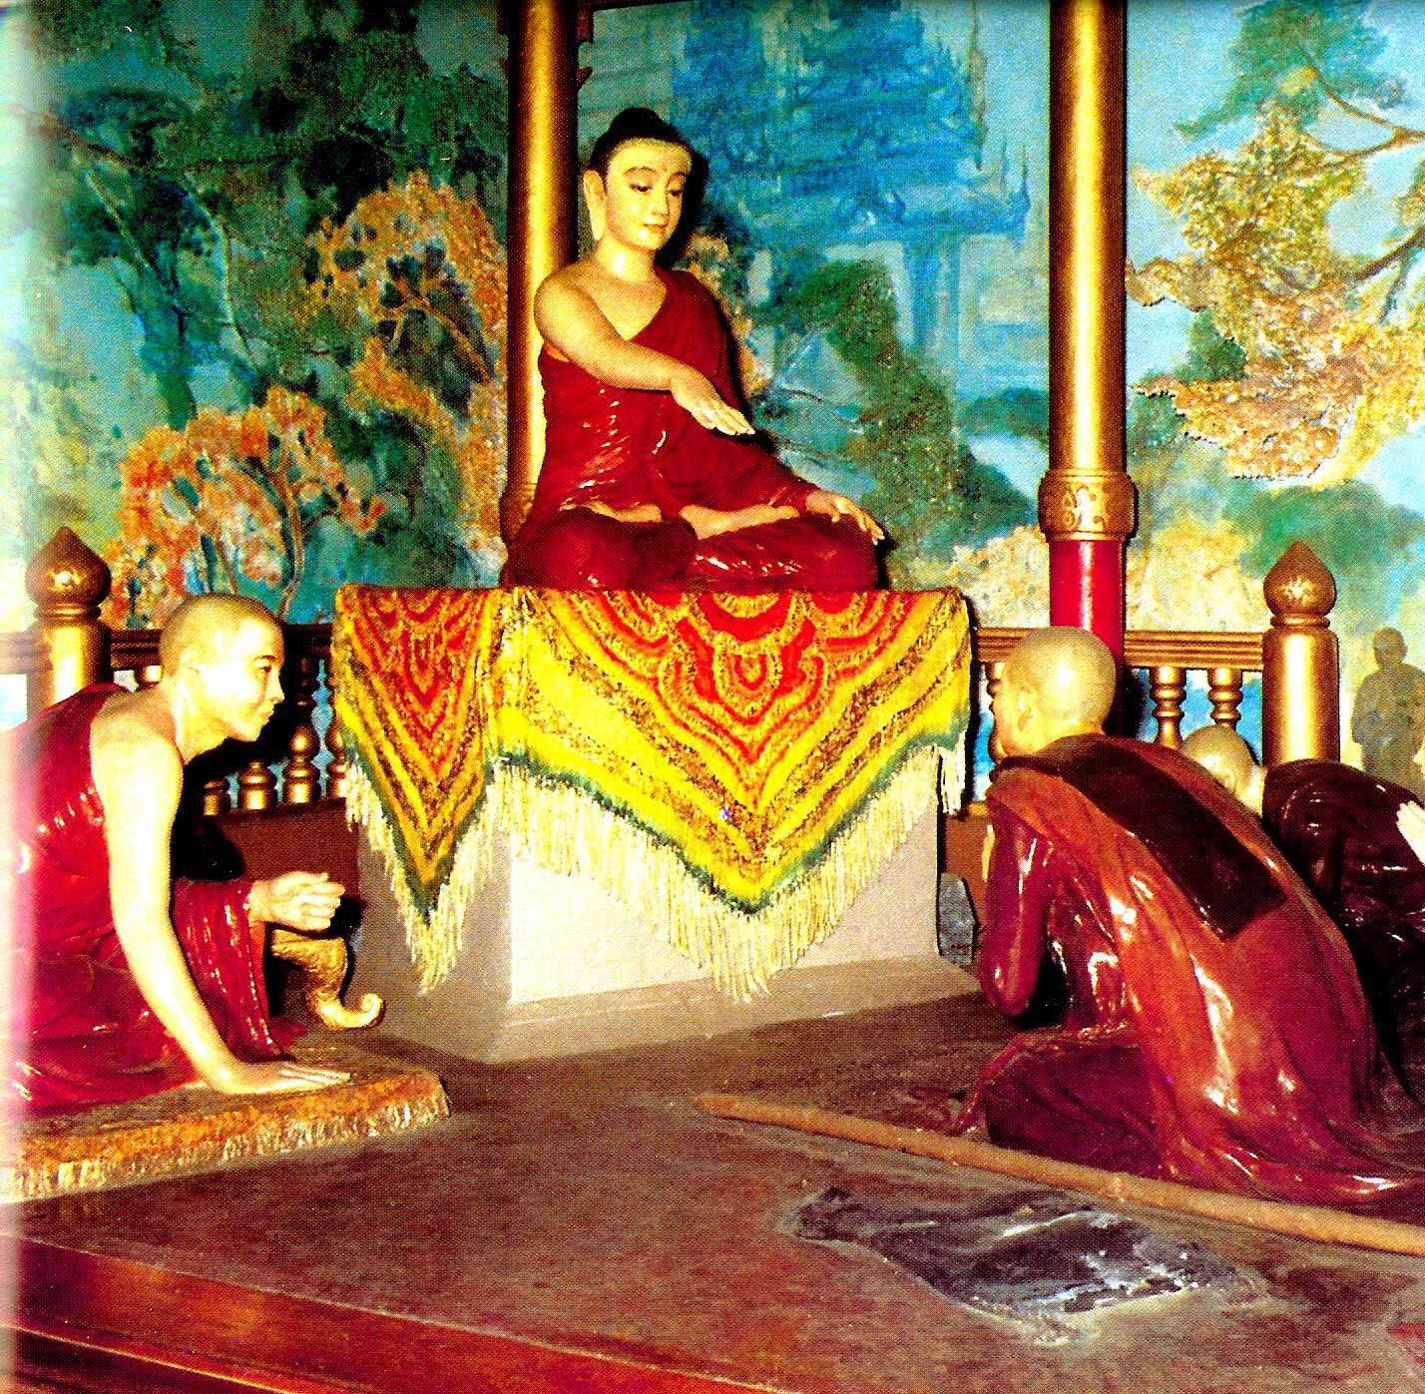
Pajapati Gotami and the five hundred Royal Maids were admitted and ordained as Bhikkhunis by the Buddha
There are eight preeminent Bhikkhuni’s in the Buddha’s Ministry:
- The founder of the order of nuns - Sister Pajapati Gotami
- Great Wisdom - Sister Khema
- Supernormal powers - Sister Uppalavanna
- Proficiency in the Rules - Sister Patacara
- Dhamma teaching - Sister Dhammadinna
- Meditative powers - Sister Nanda
- Energy - Sister Sona
- Fastest in realization - Sister Bhaddz Chaconne

18. Buddha Eight Glorious Victories
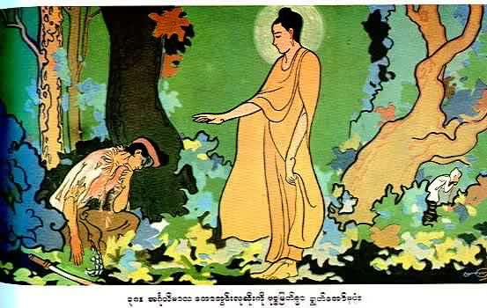
Subduing Angulimala
-

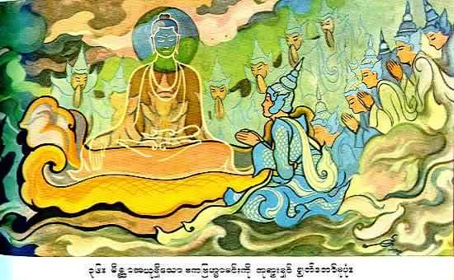
Subduing Baka Brahma - I will now show you that I can make myself invisible", and instantly the Buddha disappeared from view and preached to him a sermon while remaining invisible

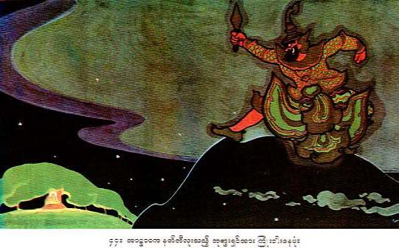
Subduing Alavaka – Yakka (Ogtr)

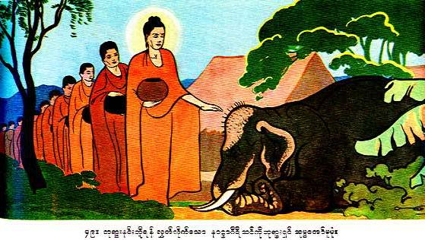
Taming the Nanagiri Elephant

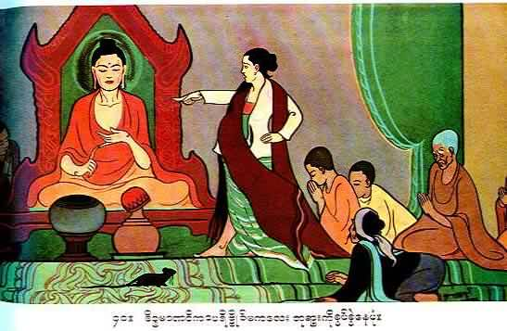
Subduing the female ascetic making false accusation
Exposing the tricks of the beautiful Cinca Manavika.

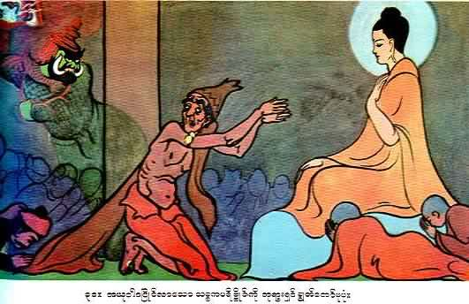
Subduing SACCAKA, ascetic .

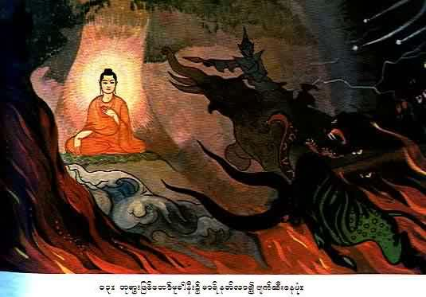
Victory over Mara

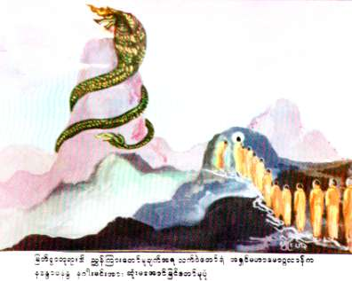

Subduing the celestial gigantic dragon, Nandopananda through Venerable Moggalana

19. Buddha’s Ministry
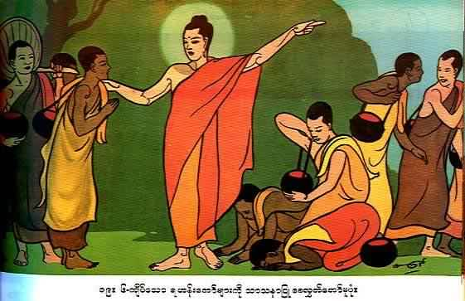
Instructing sixty of his Arahant disciple to go in all direction to preach his teaching for the good of all mankind and Gods
After the Buddha had kept his retreat at the Deer Park at Isipatana during the first rainy season, there were fully sixty Arahants besides the Blessed One. He called them and said. "Released am I, O Bhikkhus, from fetters both human and divine. Ye also are free from fetters both human and divine. Go ye, now O Bhikkhus, and wander for the gain of the many, for the good of the many, for the gain and welfare of gods and men. Preach, O Bhikkhus, the doctrine which is glorious in the beginning, glorious in the middle, glorious at the end, in spirit and in letter. Proclaim the Holy Life altogether perfect and pure. There are beings with a little dust in their eyes, who, not hearing the Doctrine will fall away. There will be those who will understand the Doctrine". With this exhortation the Buddha dispatched His first sixty disciples in various directions.
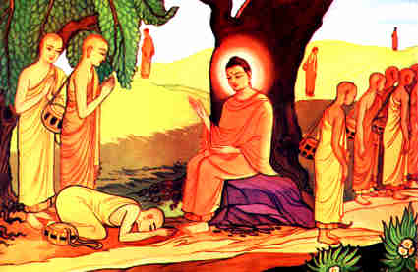
When there were 60 monks the Buddha suggested that
they now: 'Go forth, travel and teach for the welfare of the many'.
20. The Mahaparinibbana of the Lord Buddha
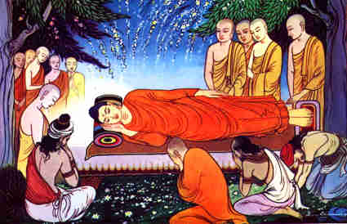
Buddha passed away in 543 B.C
From His 35th year, the date of His Enlightenment, the Buddha's successful ministry lasted 45 years. When He attained His 80th year the Buddha had an attack of dysentery and lay down on a couch with its head to the north between twin sal-trees in the Sala Grove of Kusinara State. Men, higher and lower gods and monks were gathered, in large numbers, near the Blessed One in respectful adoration.
Though he was very weak and weary, the Buddha was still addressing those present with words of exhortation. After addressing them the whole night the Blessed One spoke His last words, when it was nearing dawn, as follows:—"Behold, O disciples, I exhort you. Subject to decay are all conditioned things. Strive on with heedfulness". The Buddha then attained the Ecstasies and arrived at the cessation of perception and sensation, and finally the Blessed One passed away; and there was an earthquake to mark His death.
The Buddha was eighty years old. The time was near for the passing away (parinibbana) of the Lord Buddha. The Buddha had advised Venerable Ananda, His attending monk, that He would be passing away in three months.
The Buddha proceeded to walk to the city of Kusinara. On the way a man by the name of Pukkusa heard His Dhamma and offered Him two golden robes. As directed by the Buddha he robed the Buddha with one and Venerable Ananda with the other. When the Buddha was robed Venerable Ananda was surprised to see that the skin of the Holy One was exceedingly bright, so that the golden robe appeared dull in comparison. The Buddha informed Ananda that the Tathagata’s skin becomes clear and exceedingly bright on two occasions: the night on which He attains Buddhahood and the night on which He passes away. He then announced that on the third watch of the night He would pass away in the Sala grove of the Mallas.
It was a full moon day in the month of May. The Lord Buddha reached the Sal garden of the Mallas and saw that the twin Sal trees were in full bloom even though it was out of season. He then said, "It is not thus that the Tathagata is respected, venerated, honored and revered. Whenever a Bhikku or Bhikkuni, Upasaka or Upasika lives in accordance with the Teachings, conducts himself dutifully and acts righteously, it is he who respects, reverences, venerates, honors and reveres the Tathagata with the highest homage."
The Buddha then lay down on a couch prepared by Ananda, on His right side with His head facing north. At this time, Subhadda, a wandering ascetic, came to Him to clear up a doubt. Happy with the Buddha's teachings, he took refuge in the Buddha, the Dhamma and the Sangha, and requested permission to be a monk. He was the last personal disciple of the Buddha.
Just before the Buddha passed away many disciples came to pay their respects to Him. One monk, however, did not come. Instead, he remained in his abode, deep in meditation. On being asked the reason for his absence the monk said, "Lord, I knew that Your Reverence would pass away shortly and I thought that the best way to honor the Teacher was by attaining Arahantship before the passing away of Your Reverence." The Buddha, pleased with his reply, said: "Excellent, excellent! He who loves me should act as this monk. He honors me best who practices my teaching best."
Finally, the Buddha addressed His disciples and said these words: "Subject to change are all component things. Strive on with diligence." These were His last words. It was the full moon day in the month of May in the year 543 B.C. In the third watch of the night the Blessed One passed away.
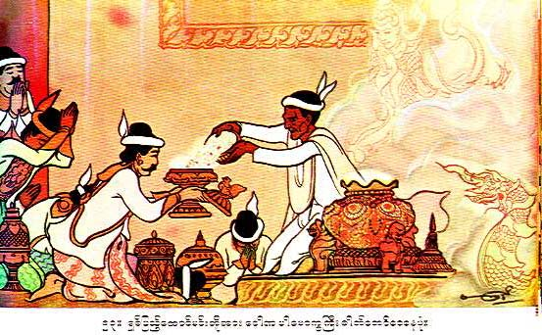
Professor Dona distributing the Buddha’s Relics
Just before the Buddha passed away, he made a resolute wish that, "the bones of my body may be left over as relics in small bits" so that posterity may reverence them. Ajattasattu and other rulers heard of the Buddha's death and came out with their own armies to fight for the possession of the sacred relies of the Buddha, if they should fail to get them by peaceful means. Dona the Brahmin was a virtuous professor who happened to have been a teacher of those rulers.
There was a great excitement and disorder amongst the crowds present who were preparing to loot the relics. Now Professor Dona got up on an eminence and shouted at the crowd in an authoritative tone, when the din was silenced. Then he spoke to the crowd beginning with the words, "Listen to me, your teacher. Our Lord, the Buddha, used to preach on forbearance". Then as agreed by the rulers of the eight states, the Professor distributed the sacred relics to them. They took the relics away and placed them inside pagodas and shrines and revered them as objects of worship.
Buddha’s Instruction
On
How to Revere the Relics of an Arahant
Dhammapada Verses 195 and 196
The Story of the Golden Stupa of Kassapa Buddha
While traveling from Savatthi to Baranasi, the Buddha uttered Verses (195) and (196), with reference to a brahmin and the golden stupa of Kassapa Buddha.
On one occasion, while the Buddha and his followers were on a journey to Baranasi they came to a field where there was a spirit-shrine. Not far from the shrine, a brahmin was ploughing the field; seeing the brahmin the Buddha sent for him. When he arrived, the brahmin made obeisance to the shrine but not to the Buddha. To him the Buddha said, "Brahmin, by paying respect to the shrine, you are doing a meritorious deed." That made the brahmin happy. After thus putting him in a favorable frame of mind, the Buddha, by his supernormal power, brought forth the golden stupa of Kassapa Buddha and let it remain visible in the sky. The Buddha then explained to the brahmin and the other bhikkhus that:
There were four classes of persons worthy of a stupa. They are: the Buddha’s (Tathagatas) who are homage-worthy and perfectly self-enlightened, the Paccekabuddhas, the Ariya disciples, and the Universal Monarchs.
He also told them about the three types of stupas erected in honor of these four classes of persons.
- The stupas where corporeal relics are enshrined are known as Sariradhatu cetiya;
- The stupas and figures made in the likeness of the above four personages are known as Uddissa cetiya; and
- the stupas where personal effects like robes, bowls, etc. of those revered personages are enshrined are known as Paribhoga cetiya. The Bodhi tree is also included in the Paribhoga cetiya. The Buddha then stressed the importance of paying homage to those who are worthy of veneration.
Then the Buddha spoke in verse as follows:
Verse 195. He pays homage to those who are worthy of veneration, whether they are the Buddhas or their disciples who have overcome obstacles (to Insight Development) and have rid themselves of sorrow and lamentation.
Verse 196. The merit gained by such a person who pays homage to those who have been freed from moral defilements arid have nothing to fear, cannot be measured by anyone, as this much or that much.
At the end of the discourse the brahmin attained Sotapatti Fruition. The stupa of Kassapa Buddha remained visible for seven more days, and people kept on coming to the stupa to pay homage and obeisance. At the end of seven days, as willed by the Buddha, the stupa disappeared, and in the place of the shrine erected to the spirits, there appeared miraculously, a big stone stupa.

The Sacred Relics of Arahants
Like the Relics of the Buddha, the Arahant's Relics can be venerated in this Buddha's Sasana . When the remain of an Arahant is cremated , the flesh and blood are gone to ashes but the bones are left as Relics . Their colors and form, however, are not mentioned in Pitaka scriptures
21. The Buddha’s Legacy
"Do no evil, Do good, Purify the mind."

1. The Buddha wanted us to study, investigate and understand His teachings, only accepting them when we found them to be moral and conducive to the well-being and happiness of mankind. The Buddha said, "Do not accept anything on mere hearsay, tradition, rumors, inference, preconceived notions, supposition, or because it seems acceptable. Do not accept anything because the ascetic who taught it is respected by all ...".
2. The Buddha advised us that at no time should we ever insult or condemn the religion of another. Intolerance is the greatest enemy of religion. Denouncing unfair criticism of other faiths the Buddha states, "It is as a man who looks up and spits at heaven. The spittle does not soil the heaven, but comes back and soils his own person." On another occasion the Buddha said, "If you find truth in any religion, accept that truth."
3. The ordinary precepts that Buddhists follow are not commandments but modes of discipline (sikkhapada) that they take of their own accord. In Buddhism we are not forced or commanded to do anything. We follow the teachings of the Buddha of our own free will because we understand and believe in them.
4. Buddhism teaches non-violence. In the Dhammapada (Law Verses) the Buddha said:
"All fear the rod,
Life is dear to all.
Feeling for others as for yourself
You should neither slay,
Nor cause others to slay."
Following, understanding and accepting the teachings of the Buddha, Buddhists take the first precept 'panatipata veramani sikkhapadam samadiyami' which means 'I undertake to observe the precept of abstaining from destroying living beings'.
To the unique credit of Buddhism, it must be said that throughout the peaceful march of 2600 years, no drop of blood has been shed in the name of the Buddha, and no mighty monarch has wielded his powerful sword to spread the Dhamma.
5. The Buddha taught us to be compassionate to all living beings. In the Karaniya Metta Sutta the Buddha said:
"As a mother protects her only child,
Even at the risk of her own life,
Let one cultivate boundless thoughts of loving kindness.
Towards all living beings."
6. The Buddha taught us that we must show love and kindness to our enemies and those we do not like. He did not believe in revenge and an eye for an eye. In the Dhammapada the Buddha said:
"Conquer anger by loving kindness.
Conquer evil by good.
Conquer the stingy by liberality.
Conquer the liar by truthfulness."
7. The Buddha advocated equality for all mankind. He attempted to abolish slavery and the degrading caste system in Indian society. He declared:
"By birth is not one an outcaste,
By birth is not one a brahmin.
By deeds is one an outcaste,
By deeds is one a brahmin."
According to the Buddha's teaching, caste or color do not prevent one from becoming a Buddhist or joining the order of the Sangha (Buddhist monks). Fishermen and scavengers, together with warriors and brahmins were freely admitted to the order of the Sangha and given positions of high rank.
Upali the barber was chief disciple in matters pertaining to the discipline of the Sangha (Vinaya). Sunita, who was honored by kings as an Arahant was a scavenger. Rajjumala and Punna were slave girls.
8. The Buddha also raised the status of women by starting the order of the Nuns. He saw the good in both men and women. Gender is no barrier to spiritual development and religious service. At that time in Indian society women were often treated as inferior to men. When Queen Mallika gave birth to a baby girl, the Buddha comforted the distraught King Pasenadi by saying:
"A female child may prove even better than a male offspring."
9. Rebirth and kamma are also integral parts of Buddhism. According to the teachings of the Buddha, life does not end at death. One is reborn instantaneously. Our life is a result of our kamma. We are not brought to this world by anyone but ourselves. It is the result of a cause. The cause is delusion (avijja). To understand this theory, we need to develop our minds through meditation.
Kamma means action. Vipaka means results. Good actions cause good results. Bad actions cause bad results. The Buddha said, "Whether you are in the sea, the air, or in a cave, you cannot hide from the effects of your bad kamma." That is the Law of Kamma. It must be stressed, however, that it is the intention behind the action and not just the action alone that sets off the reaction (vipaka). As Buddhists we refrain from bad actions and perform good actions because we know that one day, either in this birth or in a future birth, the effects of our actions will come back to us. We know that not even the Buddha can save us from the effects of our bad actions.
As Buddhists, we understand that due to the Law of Kamma, bad things can happen to a good person just as good things can happen to a bad person. We see the bigger picture. We go back into our past lives and understand that these are the results of our past bad actions. As such, we do not blame any divine powers for our misfortunes. Knowing that we are now paying for the results of our past bad actions, we take heed and ensure that we improve and not make the same mistake again. We learn from our misfortunes by doing good and avoiding bad actions.
10. The Buddha taught us that you are your own savior. No all-powerful God can help us to attain Nibbana. No God can help us to escape from the effects of our own actions. As such, you make your own destiny. Mind is supreme. In Buddhism we learn to control our minds and our destiny. We rely on no one but ourselves. The Buddhas show us how. They are our teachers. It is up to us to follow Their teachings of the Noble Eightfold Path, to control and purify our minds through meditation and attain our own salvation. The teachings of all Buddhas can be summed up in three lines:
"Do no evil, Do good, Purify the mind."

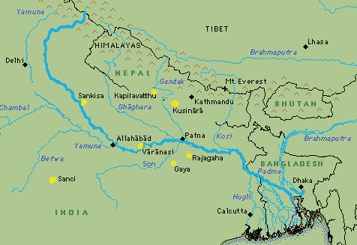
Map showing the Cities

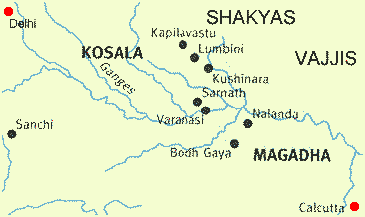

Enlarged Area Map
The area of the Ganges Plain around which the Buddha's life centered
Appendix – A

The Duration of the Sasana of Buddha Gotama

During the period, from the time of Buddha Gotama to the minimum life span, the Buddha's Dispensation (Buddha-sasana) will disappear. When the Buddha agreed to create the Bhikkhuni Sangha, he told Ven. Ananda that the Sasana would last only half as long because of this. Instead of lasting one thousand years, it would last five hundred years.

The commentary on the Abhidhamma text, Dhammasangani, says that when the First Buddhist Council convened by Ven. Maha-Kassapa rehearsed the Pali Canon, this made it possible for the Sasana to endure for five thousand years.[48]

The commentaries on the Vinaya Pitaka[49] and the Anguttara-nikaya [50] say that the eight important rules which the Buddha gave to the Bhikkhuni Sangha will make his Teachings last for five thousand years rather than five hundred.

    - There will be one thousand years for Arahats who attain analytical insight,
    - one thousand years for Arahats without those attainments,
    - one thousand years for Non-returners,
    - one thousand years for Once-returners, and
    - one thousand years for Stream-winners.

After these five thousand years of penetration of the true Doctrine (pativedha-sadhamma),[51] the accomplishment in the texts (pariyatti-dhamma) will remain. After the accomplishment in the texts disappears, the signs (linga) will continue for a long time.

In the commentary to the Theragatha[52] the Sasana is said to consist of five periods:

- the age of deliverance (vimutti-yuga),
- the age of concentration (samadhi-yuga),
- the age of morality (sila-yuga),
- the age of learning [the texts] (suta-yuga), and
- the age of generosity (dana-yuga).

Ven. Dhammapala says, concerning the disappearance of learning, "In a region where there is no purity of morality, accomplishment (in the texts) remains through taking up great learning, through the desire to acquire, etc. But when accomplishment in the summary [i.e., the Patimokkha] is completely ended, it disappears. From that time on, only the mere sign (linga) remains. Then, having accumulated riches in various ways, they give away gifts (dana); this, truly, is the last right practice.

Then, [the period starting] after the disappearance of learning is the last time (pacchima-kala). Others say that it is from the time of the disappearance of morality."

According to the tradition in Burma, the Sasana will last five thousand years. The five periods will occur twice. The first half of the Sasana has just passed, with each of the five periods lasting five hundred years. We are now in the second half, when these periods will be repeated, each lasting for another five hundred years.

In the Anagatavamsa commentary, the Buddha is said to preface
the account of the future Buddha Ariya Metteyya by saying his own dispensation will disappear in five stages:
- the disappearance of analytical insight (patisambhida),
- the disappearance of the Paths and Fruition States,
- the disappearance of the practice (patipatti),
- the disappearance of the texts (pariyatti), and
(5) the disappearance of the Sangha.

Other commentaries also speak in terms of five stages of disappearance (antaradhana) of the Sasana:[53]

- First, there will be the disappearance of attainment (adhigama), which would correspond to the age of deliverance.
- The second disappearance is of the practice (patipatti), which corresponds to the ages of concentration and morality.
- The disappearance of accomplishment in the texts (pariyatti) is third and corresponds to the age of learning.
- The fourth disappearance is of the signs (linga). During this period, the only good action left is making gifts to those who wear a yellow strip of cloth around their necks, so this would correspond to the age of generosity. When this disappearance occurs, five thousand years will have passed.[54] After this period there occurs
- the disappearance of the relics (dhatu). When the relics no longer receive honor, they will assemble at the seat where the Buddha attained Awakening under the Great Bodhi tree. There, they will make an effigy of the Buddha and perform a marvel similar to the Twin Marvel and will teach the Doctrine. No human being will be present, only Devas from the ten thousand world systems will listen, and many of them will attain release. After that, the relics will be burned up without remainder.[55]

FOOTNOTES:
  - As 27, see Expos. 35.
  - Sp 1291.
  - Mp IV 136f.
  - Ven. Ledi Sayadaw (MB 169) calls these five thousand years the age of Ariyas (Noble Ones).
  - Th-a III 89.
  - ] See the commentary on A (Mp I 87), Moh 201-203, and the extract from the Anag commentary (JPTS, 1886, pp. 33-36; translated in BT 481-486).
  - The number of years is mentioned only in the Anag commentary.
  - Some texts speak of three disappearances. See CPD under antaradhana for references.

Source - http://www.ubakhin.com/uchittin/arimet/ARIMET03.html

Bibliography

- Dhamma Dana by Radhika Abeysekera
- YMBA – Young Men Buddhist Association of Myanmar – Illustration
- http://www.abm.ndirect.co.uk/leftside/index-pop.htm by Ajahn Chah. For more illustration
- Dhammapada by Daw Mya Tin – Tipitaka Association
- Nibbana.com – for preeminent Disciples.
- Museum of Buddha History – Yangon, Myanmar

Sadhu! Sadhu! Sadhu!
May You All be Well

