The Birth of the Great Sage
Gotama Buddha
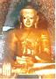

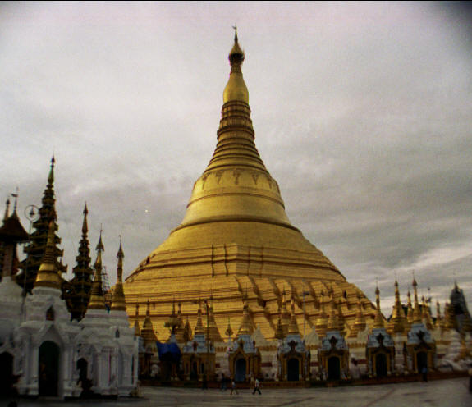
The Path to the Cessation of Sufferings
Nibbana

Namo Tassa Bhagavato Arahatto Sammasambuddhassa
The Birth of the Great Sage
Gotama Buddha
PREFACE
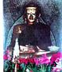
The Sage who dispenses his teaching to both Men and Gods the way to liberation from the 31 Planes of Existence (Samsara)(The Cycle of birth and rebirths)
The Great Sage has Given his Teaching Freely
To all those who love to follow his Teaching
I therefore have no right to claim his Dhamma
This is a Gift of Dhamma

By the Most Compassionate Buddha Gotama
May All Aspirants Find their Way
to
Nibbana
Namo Tassa Bhagavato Arahatto Sammasambuddhassa
The Birth of the Great Sage
Gotama Buddha

CONTENTS
      - Aspiration to be the Future Buddha
      - Invitation of the Gods
      - Queen Maha Maya's Dream
      - The Birth of a Prince
      - Ploughing Festival
      - The Story of the Swan
      - His Marriage
      - The Four Signs
      - The Great Renunciation
      - The Ascetic Sidhatta
      - Sujata Offers milk Rice
      - Enlightenment
      - The Seven Weeks After Enlightenment
      - His Hair Relics given to Saputta and Bhalika
      - The First Sermon
      - The Teachings of the Buddha
      - The Establishment of Bhikkhuni Sangha’s Order
      - Buddha’s Eight Glorious Victories
      - Buddha’s Ministry
      - The Maha Parinibbana of the Lord Buddha
      - Buddha’s Legacy
Map of India

Appendix – A The Duration of the Sasana of Buddha Gotama
Bibliography

1. Aspiration to be the Future Buddha
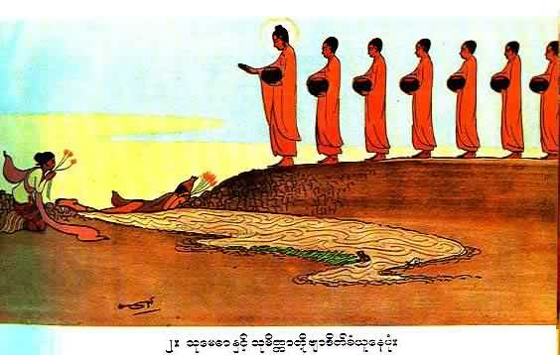
Bodhisatta Ascetic Sumedha offered his body fro Buddha Dipankara and his five hundred Arahants to tread on, as a bridge over the muddy stream.

Bodhisatta Sumedha Ascetic received the first definite prophecy (Byar Deik taw) Prophecy from Dipankara Buddha that he would be the fourth Buddha Gotama in the Buddha Kappa to come. Bodhisattva waited through so many world cycles, in fact, through twenty four Buddhas, before he completed his perfections to arise in this Buddha Kappa as Gotama Buddha.

Starting with Buddha Dipankara and the twenty three successive Buddhas, each and every one gave him a definite prophecy that he would be the Buddha Gotama in this world cycle know as Buddha Kappa. Imagine just how long it took him to complete the ten perfections to be a self-enlightened Buddha – Summa Sambodha – the teaching Buddha..
1. Dipankara Buddha - The Bodhisatta was born as the ascetic Sumedha and received the definite proclamation
After a period of one Asankheyya there appeared:
2. Kondanna Buddha - The Bodhisatta was a Cakkavatti King named Vijitavi
After a period of one Asankheyya there appeared:
3. Mangala Buddha - The Bodhisatta was a Brahmin named Suruci
4. Sumana Buddha - The Bodhisatta was a Naga king named Atula
5. Revata Buddha - The Bodhisatta was a Brahmin named Atideva
6. Sobhita Buddha - The Bodhisatta was a Brahmin named Ajita
After a period of one Asankheyya there appeared:
7. Anomadassi Buddha - The Bodhisatta was a leader of demons
8. Paduma Buddha - The Bodhisatta was a lion
9. Narada Buddha - The Bodhisatta was an ascetic
After a period of one Asankheyya there appeared:
10. Padumuttara Buddha - The Bodhisatta was a man named Jatila (This period was 100,000 Maha kappas before the advent of the Gotama Buddha)
After a period of 70,000 Maha kappa there appeared:
11. Sumedha Buddha - The Bodhisatta was a young man named Uttara (This period was 30,000 Maha kappas before the advent of the Gotama Buddha)
After a period of 12,000 Maha kappa there appeared:
12. Sujata Buddha - The Bodhisatta was a chakkavatti king (This period was 18,000 Maha kappas before the advent of the Gotama Buddha)
13. Piyadassi Buddha - The Bodhisatta was a young Brahmin named Kassapa
14. Atthadassi Buddha - The Bodhisatta was an ascetic by the name of Susima
15. Dhammadassi Buddha - The Bodhisatta was the God Sakka
16. Siddhatta Buddha - The Bodhisatta was an ascetic by the name of Mangala
17. Tissa Buddha - The Bodhisatta was a king named Sujata who later became an ascetic (This period was 92 Maha kappas before the advent of the Gotama Buddha)
18. Phussa Buddha - The Bodhisatta was a king by the name of Vijitavi who later became a monk
19. Vipassi Buddha - The Bodhisatta was the Naga king, Atula (This period was 91 Maha kappas before the advent of the Gotama Buddha)
20. Sikhi Buddha - The Bodhisatta was a king named Arindama (This period was 31 Maha kappas before the advent of the Gotama Buddha)
21. Vessabhu Buddha - The Bodhisatta was the king Sudassana who later became a monk (This period was one Maha kappa before the advent of the Gotama Buddha)
22. Kakusandha Buddha - The Bodhisatta was a king named Sema (This period was in the same Maha kappa as that of the Gotama Buddha)
23. Konagamana Buddha - The Bodhisatta was a king named Pabbata who later became a monk (This period was in the same Maha kappa as that of the Gotama Buddha)
24. Kassapa Buddha - The Bodhisatta was a Brahmin named Jotipala (This period was in the same Maha Kappa as that of the Gotama Buddha)/
Unlike PeccakaBuddha, a summa sambudha, a teaching Buddha, must fulfill all the ten perfections in the given duration as shown above.

The Ten Perfections
Pali | English
Dana | Generosity
Sila | Morality
Nekkhamma | Renunciation
Panna | Wisdom
Viriya | Energy
Khanti | Patience
Sacca | Truthfulness
Aditthana | Resolute Determination
Metta | Loving Kindness
Upekkha | Equanimity

2. Invitation of the Gods
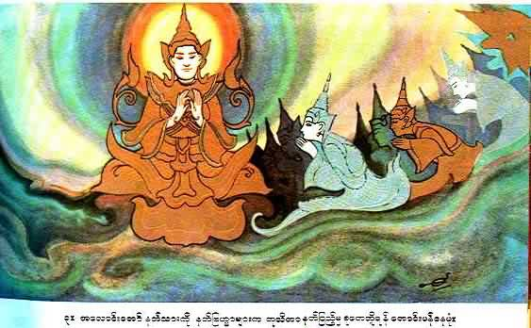
Gods inviting the Bodhisatta ,(Svetaketu Deva) in Tusita heaven to take a rebirth as next Buddha in the human realm.
The Devas invited the Bodhisatta (Svetaketu Deva) in Tusita Heaven, to be born on earth, for the last time in the Samsara, as Gotama Buddha as prophesied by the past twenty four Buddha’s.
The Bodhisatta then assesses the world for five conditions:
1. The Right Time - The life span of human beings at a time a Buddha is born is between 100 and 100,000 years.
2. The Right Continent - All Buddha’s are born in India (known as Jumbudipa at the time of the Buddha).
3. The Right Area - The city of Kapilavatthu was chosen as the city of the future Buddha, as there was a just and good king and many righteous people living there.
4. The Right Caste - A Buddha is always born in a high caste - Either a royal caste or a priestly caste (Brahmin).
5. The Right Mother - The mother of a Buddha has to be very pure. She is a person who has resolved to be a mother of a Buddha and observed the five precepts for many countless past lives.
When he saw that all the five conditions were met, he descends to earth in the womb of Maha Maya.
3. The Queen Maha Maya's Dream
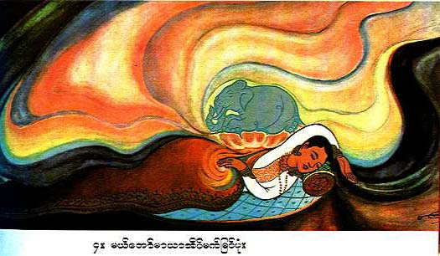
The Queen Maha Maya’s Dream
He descended to the womb of the Queen, Maha Maya, wife of King Suddhodana.
The Queen Maha Maya dreamt that the Devas from the four directions of the earth took her to Lake Anotatta on top of the Himalayan Mountain. She was bathed in the lake and dressed in heavenly clothes and ornaments. A white baby elephant carrying a white lotus flower in its trunk trumpeted, and after circling around her three times, entered her body.
The Birth of a Prince
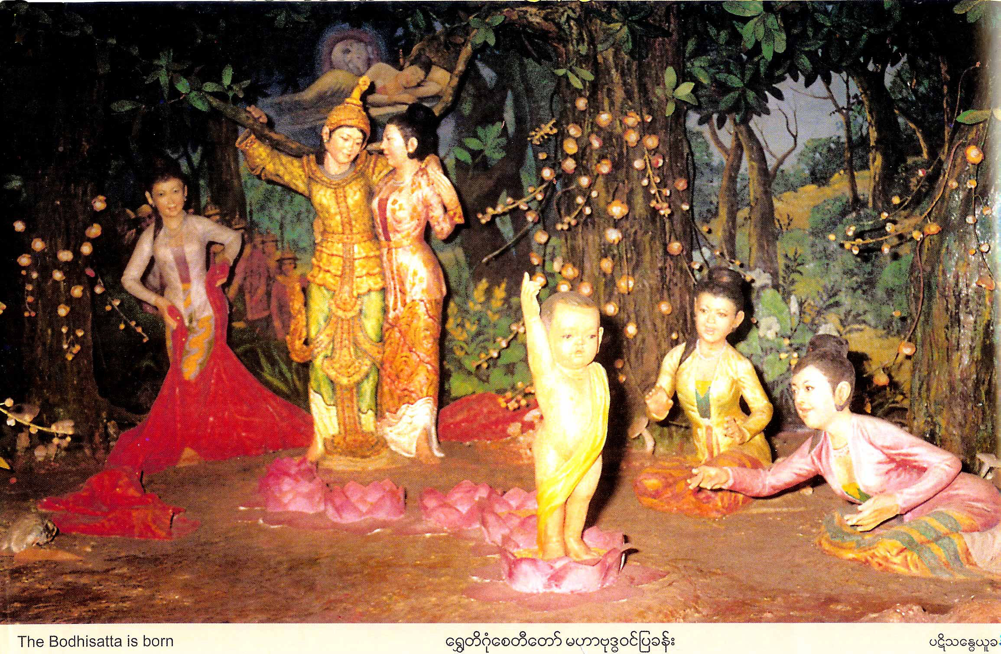
Prince Sidhatta was born at Lumbini Pleasure Garden
It was the custom of that time for the Queen Maha Maya to visit her mother at the time of the birth of her baby. On the way she stopped at the Lumbini Pleasure Garden to rest. Under a sweet-scented Sal tree, on a full moon day in the month of May, in the year 623 B.C., the Prince was born.
The baby Prince took seven steps, and a lotus flower burst through the ground to receive His feet. He made the following announcement:
"Aggo hamasmi lokassa "I am the Chief in the world
Jettho hamasmi lokassa There is no equal to me
Settho hamasmi lokassa I am Supreme
Ayamanthima jathi This is my last birth
Natthi dani punabbhavo." No rebirth for me."
Many wise men came to see the baby. They said that one day the Prince would either be a King of the world or a Supreme Buddha. The baby Prince was named Siddhartha Gotama. Siddhartha means "wish fulfilled" and Gotama was His family name.
Seven days after the birth of the Prince, Queen Maha Maya died. She was born as a Deva by the name of Matu-deva putta in the Tusita Heaven. Her sister, Maha Pajapati Gotami, took care of the Prince.
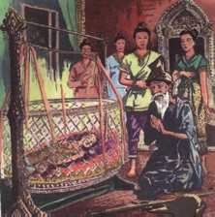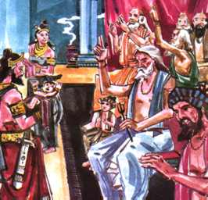
Asita the sage weeps - he sees the child will become enlightened but knows that he will be dead before the Buddha begins to teach.

Eight brahmin priests predict the child's future - seven say 'a Buddha or a great King' only Kondanna (the little chap in the middle) says 'A Buddha!' This was the time when the baby was named - Siddhattha, 'a wish fulfilled'.

4. Ploughing Festival
Mae Daw Maha Maya – Sidhatta’s mother - Seven days later after he was born, the Queen Maha Maya passed away. Her Sister, Maha Pajapati Gotami, who was the second consort of King Shuddhodana, nursed and took care of the baby Prince.
Queen Maha Maya was reborn as a male Deva by the name of Matu Deva Putta in the Tushita heaven. Later she passed away from the Tushita heaven to the Tavatimsa Heaven to hear the Abhidhamma, the Higher Teachings. The Buddha dispensed the Higher Teachings for three months in the Tavatimsa heaven to a multitude of Devas presided over by his former mother.
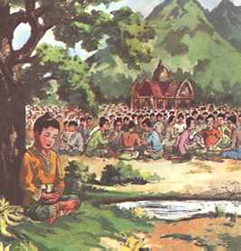 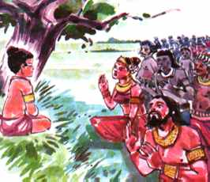 Rose Apple tree in meditation while the festivities continue
Siddhattha sits under the Rose Apple tree in meditation while the festivities c
King Suddhodana is relieved to find his son but worried that he is meditating. He wants him to be a world ruler - not a Buddha
Every year there was a big festival at the time the rice fields were ploughed. One day King Suddhodana took the little Prince to the ploughing festival. The Prince fell asleep. Seeing that the Prince was sleeping, His maids joined in the festivities of the day.
When they came back they found the Prince deep in meditation. He was meditating on His breathing in and breathing out. This meditation is known as breathing meditation (anapana Sati Meditation). This form of meditation is very important, as it was this meditation that was later used by the Buddha to attain enlightenment

Buddha Kappa – Auspicious World cycle – five Buddhas will arise
Summa Sambodha – Teaching Buddha – self-enlightened one to teach dhamma to sentient beings – Gods, Brahmas and human.
Peccakabodha – solitary Buddha – a private Buddha entering Nibbana on his own.
Deva – Heavenly beings – Gods – See 31 planes of existence).
Bodhiasatta - This is the name given to a person who is trying to be a Buddha.
Tusita Heaven - The Devas in the Tusita Heaven have a life span of 576,000,000 human years. All Bodhisattas who have completed the ten perfections waits the right time for their last birth in Tusita Heaven. The next Buddha, the Mettreyya Buddha, is at present a Deva by the name of Natha in the Tusita Heaven.
enlightenment - the supreme knowledge that leads to the end of rebirth

