Buddha’s Prophecy

on

Tapussa and Bhallika Brothers

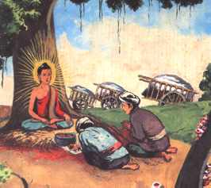
Two merchants, Tapussa and Bhalluka stopped to offer food to the Buddha. They took refuge in Buddha and Dhamma and became the very first lay Buddhists.

CLICK on the Realplayer Clip

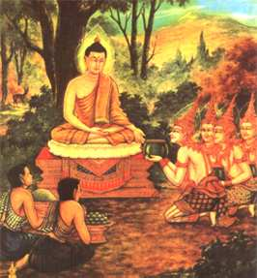

CLICK on the Realplayer Clip

The Buddha had no bowl with him so the gods of the four quarters came with a bowl each. The Buddha merged these four bowls into one

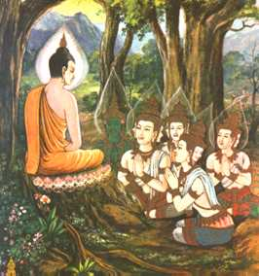

The Buddha wondered whether anyone would understand what he had realised and he doubted the value of teaching. The Brahma god Sahampati came before him and begged: 'There are, good sir, those with just a little dust in their eye. Pray, teach for their benefit.'

